Instagram User Analytics

Project Description

Instagram is widely used social networking service. Interactions and engagement done with the Instagram application need to be analysed to provide valuable insights to the business grow .Analysis of data done by tracking how users engage with a digital product, such as a software application or a mobile app. Based to the analysis insights will be taken to help the product manager and the rest of the team to make informed decisions about the future direction of the Instagram app. the marketing team might use these insights to launch a new campaign, the product team might use them to decide on new features to build, and the development team might use them to improve the overall user experience.

Approach

The dataset collected is converted to SQL tables to gather information required for the analysis. More than one table are used to find the dependences and relationships to retrieve the insights. Based on the queries proposed for Marketing Analysis and Investor Metrics the data insights are taken to give complete and accurate results.

Tech-Stack Used
My SQL Workbench 8.0 community version is used to perform the tasks. It has a good graphical user interface which allows to execute the queries with ease.

Insights:

- Querry 1
The below query is written to identify the five oldest users on Instagram from the provided database who were using the platform for the longest time to help the marketing team to reward the user

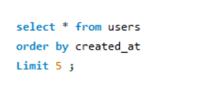
Result:

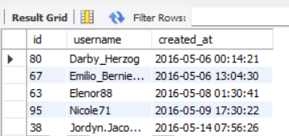

The above-mentioned users are the 5 top most oldest users on Instagram who will be rewarded.

- Querry 2:

The below query identify users who have never posted a single photo on Instagram which helps user engagement team to encourage inactive users to start posting by sending them promotional emails.

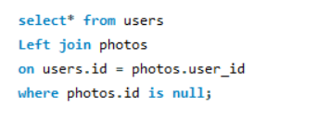
Result:

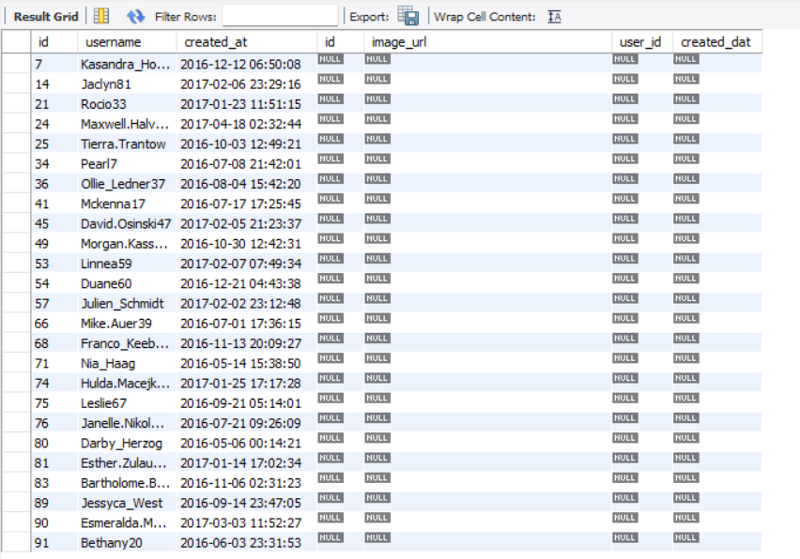

Above mentioned are inactive users to whom the team needs to send promotional emails to encourage them to be active on Instagram.

- Querry 3:

Below query identifies the most likes on a single photo to find out winner of the contest with their details to the team.
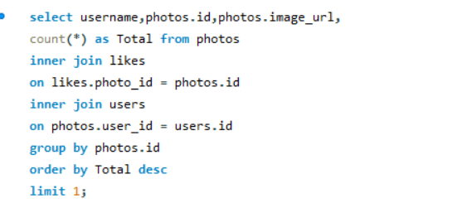
Result:

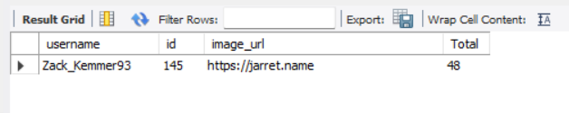

Zack_Kemmer93 with id 145 has got total of 48 likes and has been declared as the winner of the contest.

Querry 4
Below query is used to help the partner brand to identify the top five most popular hashtags to use in their posts to reach the most people.

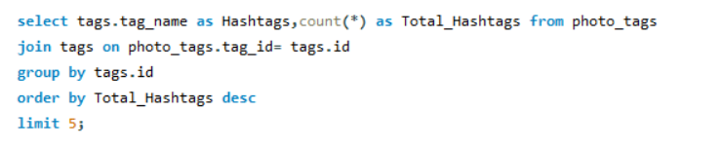
Result:

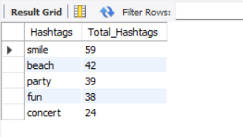

The above mentioned are the popular top 5 hashtags which will help the team to reach the most Instagram users.

Querry 5
Below query gives the best day of the week to launch ads for Ad Campaign retrieving results for day of the week when most users register on Instagram.
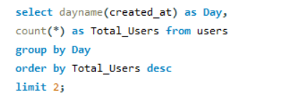

Result:

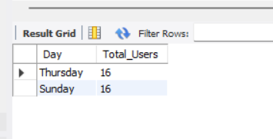

Thursday and Sunday are the days of the week when the team can launch ads for Ad Campaign, as most of the users are registered on Instagram.

Querry 6

The below query gives average number of posts per user on Instagram to understand if users are still active and posting on Instagram or if they are making fewer posts.

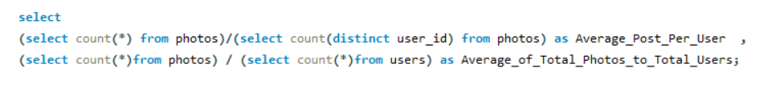
Result:

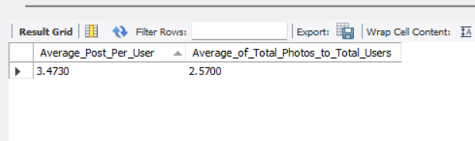

There are 3,4730 average post per user and 25700 is the average of total posts to total users in Instagram as per the data.

Querry 7

- The below query helps the investors to know if the platform is crowded with fake and dummy accounts by fetching details of users (potential bots) who have liked every single photo on the site.

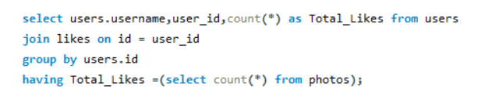
Result:

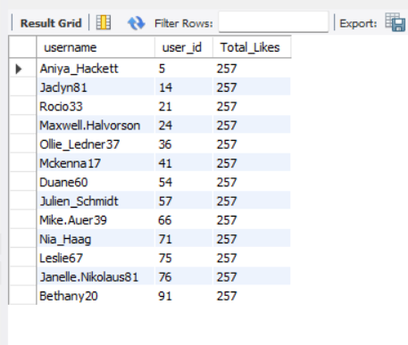

Above mentioned is the list of users with user_id and username who fake and dummy accounts and liked every single post.

Drive Link

The insights will help the development and marketing teams make good decisions. It will encourage the users of Instagram to be more active with improved version and friendly GUI. Different campaigns will be conducted based on the insights which will improve the overall user experience.

https://drive.google.com/drive/folders/1rAJr8OjvTlOzrcd_ckhmbj43VCyijD_U?usp=drive_link

Thank You

